AALS CLINICAL SECTION NEWSLETTER

SPRING 2022
In This Issue
Page 1: From the Clinical Section Chairs
Page 2: Program Updates
Page 18: Committee Announcements
Page 19: Upcoming Meetings and Conferences

Welcome to the Spring 2022 AALS Clinical Section Newsletter. We, your editors, are pleased to bring you exciting information and updates from both the Section and from schools and programs around the country.


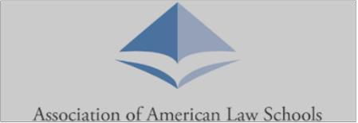


From the Clinical Section Chairs
Friends and Colleagues,

As we near the end of another academic year, we want to express our deep appreciation for all the amazing work you continue to do in the face of significant challenges. Clinical and externship faculty have found novel ways to support both individual clients and their local communities by tackling crucial issues including structural racism, over-incarceration, a broken immigration system, and housing and food insecurity. All the while, you strive to deliver critical real-world practical lawyering experiences for your students. We know what an undeniable source of inspiration you continue to be for so many law students who will use the foundational skills they learned in clinics and externships to continue the fight for justice and equality through their own careers.

As many of you know, the bulk of our Section’s work happens through our many vibrant committees. This year’s committees have been busy sharing ideas about clinical and externship pedagogy, helping members with scholarship, providing training for new clinicians, planning the Clinical Conference, selecting winners for the Section’s awards, and engaging in countless other large and small ways. Our current active committees include:
- Awards
- Annual Meeting
- Bellows Scholars
- Clinicians of Color
- Communications
- Externships
- Membership, Outreach and Training
- Nominations
- Policy
- Scholarship
- Teaching Methodologies
- Transactional Law Clinics

We encourage all clinicians to engage in the work of the Section through our committees and through programming at the Clinical Conference, the AALS Annual Meeting, and the Externships 11 Conference. If you would like to get involved with one of our committees, please contact us
(Cindy Wilson, c-wilson1@law.northwestern.edu and Claire Raj, rajc@law.sc.edu). Joining a committee is a fantastic way to meet new colleagues and reconnect with old friends across the country while giving back to our amazing clinical community.

Speaking of our amazing community, we hope to see (albeit virtually) many of you at our upcoming Clinical Conference. Please join us in a preliminary note of thanks to the tenacious conference planning committee, which has spent many hours putting together a truly amazing array of panels and speakers:

Carwina Weng, Indiana University Maurer School of Law, Chair
Alexi Freeman, University of Denver Sturm College of Law
Gautam Hans, Vanderbilt University Law School
Karl S. Okamoto, Drexel University Thomas R. Kline School of Law
Margaret E. (Meg) Reuter, University of Missouri-Kansas City School of Law
Kele Stewart, University of Miami School of Law

While the pandemic has forced us into yet another virtual conference, we are thrilled to be able to support local in-person gatherings through small grants meant to encourage clinicians to gather, share ideas, and strengthen the clinical community. This year the Section received and authorized funding for 7 such events around the country. We hope that these opportunities to meet in person around the time of the Clinical Conference will be energizing, educational, and fun for all the participants. Next year, all of us look forward to gathering in person at the 2023 Clinical Conference.

Finally, it is our great honor to announce the winners of two Section awards. The Section will present Professor Lisa Brodoff of Seattle University School of Law with the William Pincus Award and Professor Bernice Grant of Fordham Law School with the M. Shanara Gilbert Award. The awards presentation will take place at the virtual Clinical Conference. Please join us May 11th at 5:30 p.m. EST to honor these outstanding clinicians.

In solidarity,

Claire Raj and Cindy Wilson, Section Co-Chairs

Program Updates

American University Washington College of Law

From our Community Economic and Equity Development Law Clinic, directed by Professor Brenda Smith: “The AUWCL Community Economic and Equity Development Law Clinic (CEED) has been collaborating internally and externally to better serve our students, clients, and community. CEED will be partnering with pro bono counsel to increase our capacity for the redevelopment of Lincoln Temple, the site of the oldest Black Congregational church in the District of Columbia, into affordable housing and space for community-based organizations. CEED, along with AUWCL’s Glushko Samuelson Intellectual Property Clinic, will also be taking on the creation of a non-profit organization (the BLM Fence Organization) to memorialize the Black Lives Matter Fence and the Protest Art created and left on the Fence in Washington, DC. The Library of Congress, DC Public Library and Enoch Pratt Free Library have all stepped in to assist. Finally, CEED has created partnerships with the broader law school and university community to assist students in connecting clinical representation with skills learned in AUWCL’s Legal Rhetoric and Academic Excellence programs to support overall academic achievement and bar passage. The collaboration has resulted in rubrics for legal writing and analysis.

From our Disability Rights Law Clinic: Student Attorneys in the AUWCL Disability Rights Law Clinic obtained a financial settlement on behalf of a client whose landlord denied them a reasonable accommodation transfer for more than one year. In addition to the settlement, the client’s reasonable accommodation transfer request was finally granted.
Boston College Law School
Professor Reena Parikh and students in the BC Civil Rights Clinic successfully settled two wage theft actions on behalf of low-wage restaurant workers in partnership with the Matahari Women Workers’ Center.
Professor Daniela Urosa and students in the BC International Human Rights Practicum worked with the Public Action and Environmental Rights Clinic of the Universidad del Rosario (Colombia) and submitted amicus curiae to the Colombia Constitutional Court advocating for the elderly human rights in forcible displacement contexts. The Practicum team also submitted amicus to the Inter-American Court of Human Rights in Guevara Diaz v. Costa Rica, advocating for mentally disabled individuals' labor rights, and will join the Environmental Rights Clinic of the PUCP Peru as amici before the Fourth Constitutional Court of Lima, Peru, in defense of indigenous communities in isolation and initial contact (PIACI) rights.
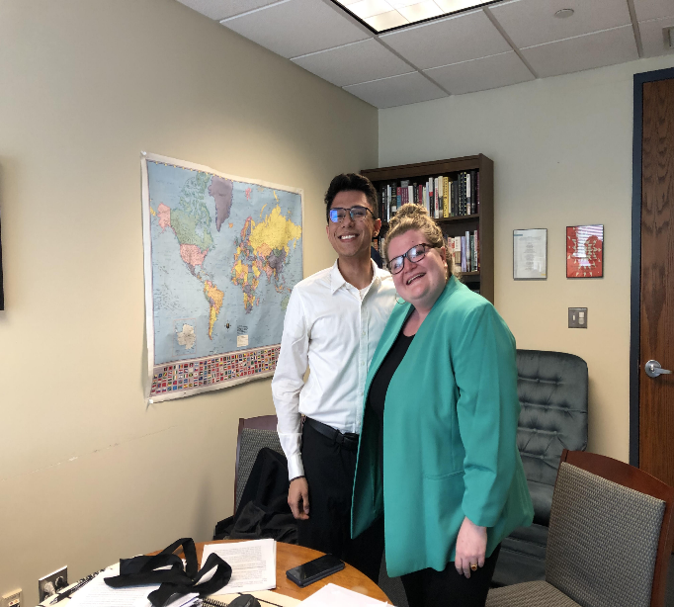
Professor Mary Holper and students in the BC Immigration Clinic won a grant of protection under the Convention Against Torture for their client, a Nigerian permanent resident who suffers from schizophrenia.
Professor Paul Tremblay has two recent publications, Introduction to Transactional Lawyering Practice (with Alicia Alvarez) (West Academic Publishing, 2d ed. 2022), and The Simultaneity Puzzle: Lawyers Working at Multiple Law Firms, 89 Tenn. L. Rev. 131 (2021).

The BC Innocence Program is litigating 5 motions for postconviction relief on behalf of wrongfully convicted clients. Professor Sharon Beckman, Staff Attorney Lauren Jacobs and clinic students collaborated with Psychology Professor Liane Young and her Morality Lab students to research and draft Model Jury Instructions on Implicit Bias that the MA SJC now requires in all jury trials. Supervising Attorney Charlotte Whitmore, Fellow Sarah Elkins, and clinic students serve on the MA Conviction Integrity Working Group developing best practices for CIUs.

Photo: BCIP team at the Innocence Network Conference in Phoenix April 7-9th.

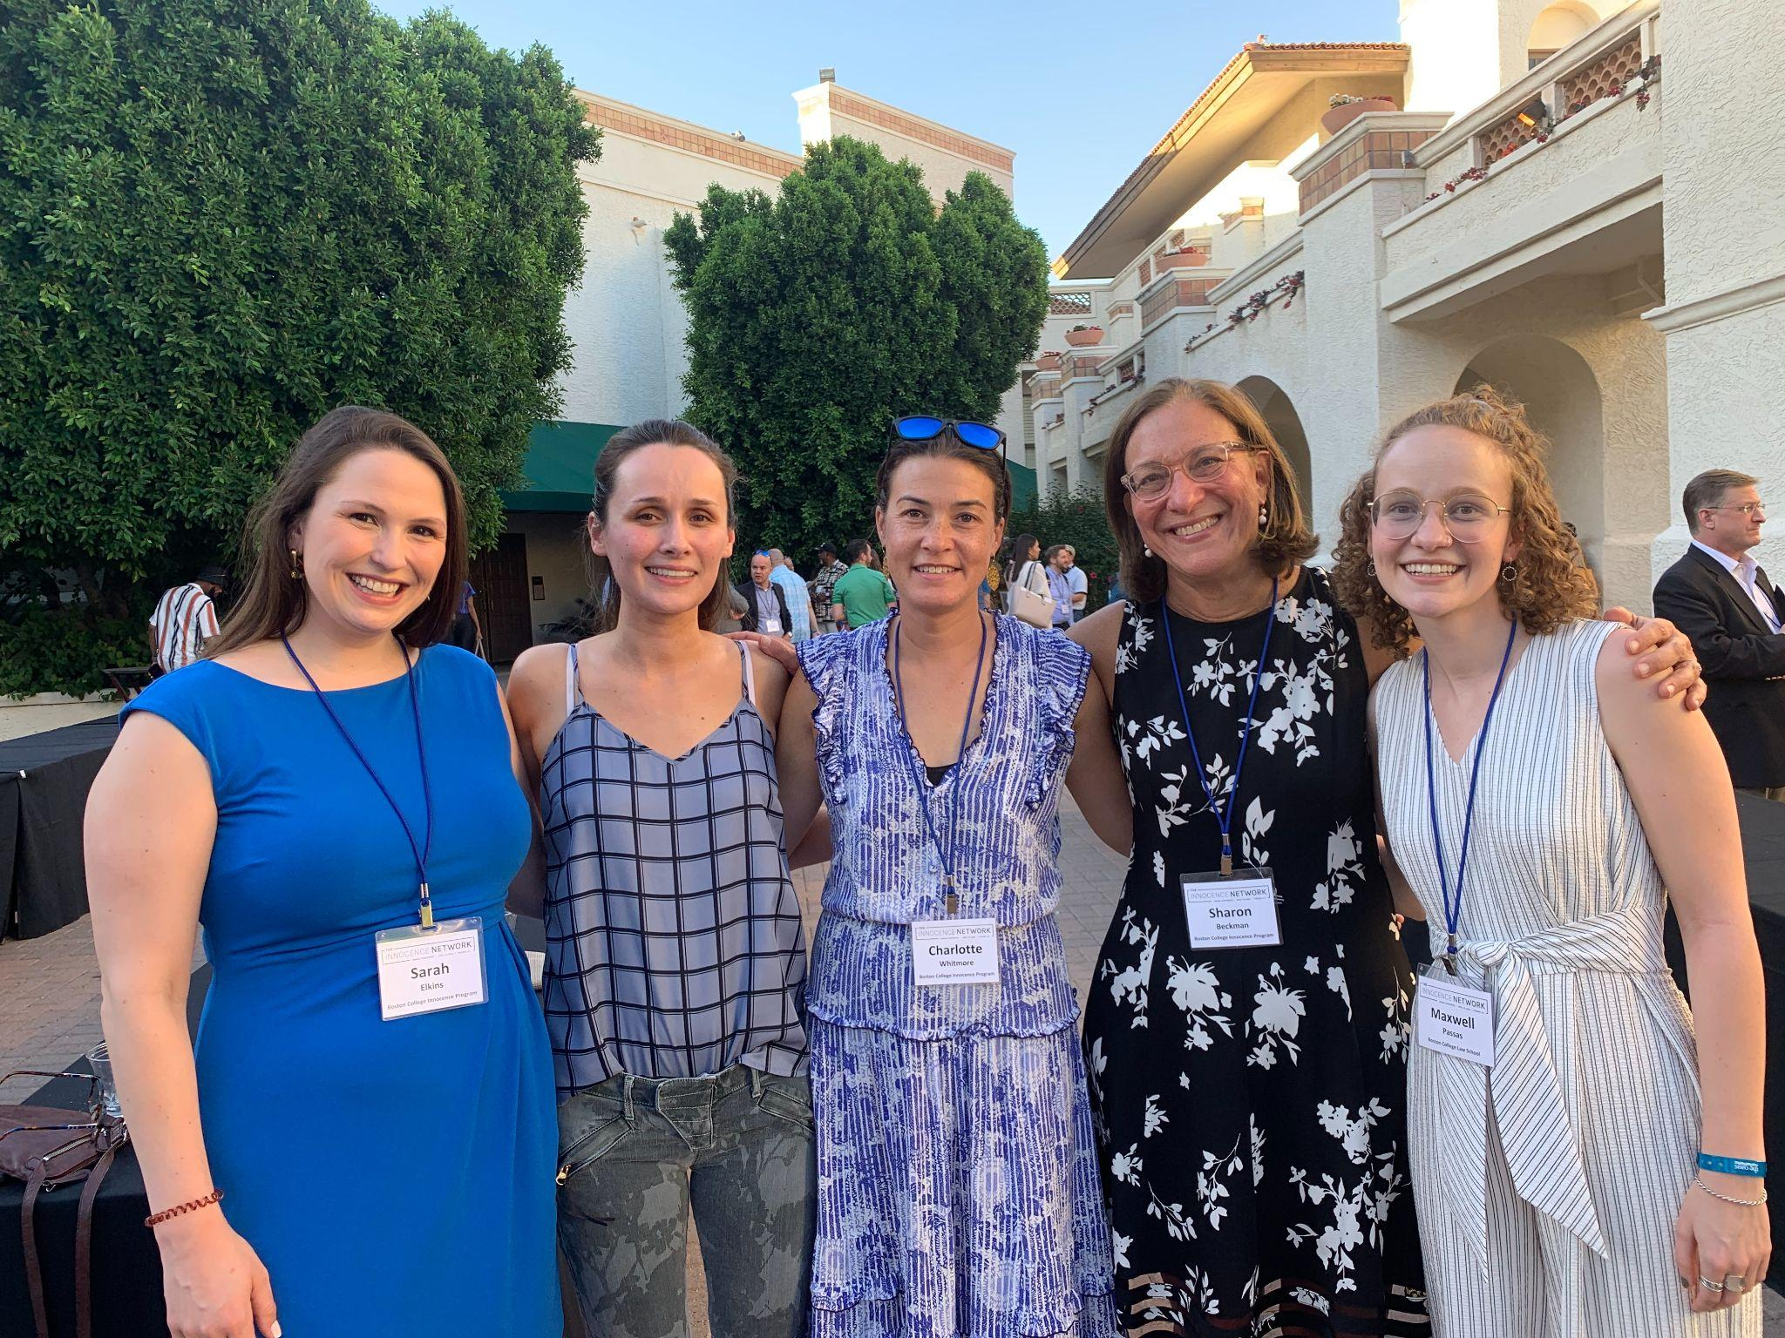

Boston University School of Law

In Spring 2022, BU Law launched the Health Justice Practicum, a policy-oriented medical-legal partnership with Boston Medical Center’s integrated medical home for pregnant and parenting people with substance use disorders. The partnership is currently working on projects related to laws and policies that result in excessive and traumatic family separations for this patient population, especially for Black families. The HJP was founded by Peggy Maisel and Danielle Pelfrey Duryea.

BU’s Legislative Policy & Drafting Clinic, led by Professor Sean Kealy, worked with Dean Angela Onwuachi-Willig to draft amendments to the Creating a Respectful and Open World for Natural Hair (CROWN) Act and advocate for its passage. Some of the clinicians’ proposals were adopted by both the House and the Senate, including extending the bill’s reach to religious schools if hair style is not specifically regulated by the religion. The Dean and clinic student Dominique McClean (’21) testified before the Legislature’s Judiciary Committee in favor of the legislation.

The BU Law Access to Justice clinic run by Professors Naomi Mann and Jade Brown, with the partnership of Dean Angela Onwuachi-Willig, contributed to keeping eviction filings below 60% of historic averages nationally following the August 2021 moratorium.

The International Human Rights Clinic has also continued its work on mapping statelessness in the MENA region. We recently completed a report on efforts to end statelessness in Egypt prepared by IHRC's 2020-21 students Chris Creech, Raven Pitarra and Hope Modugno and a report on statelessness in Iraq, prepared by the clinic in collaboration with independent consultant Zahra Al-barazi. In December 2021, with partners at the Center for Migration and Refugee Studies at the American University in Cairo, the Clinic co-organized a conference to launch the first of its kind online platform for knowledge exchange and advocacy around statelessness in the MENA (https://www.statelessmena.com/).
Columbia Law School

Lawyering in the Digital Age Clinic (LDA), directed by Professor Conrad Johnson, has been deeply involved in addressing issues arising in the Housing Court and other venues during the pandemic, including the challenges of virtual proceedings, the digital divide, and the disparate impact of the crisis on communities of color. Professor Johnson and the students have made presentations to groups of state and local legislators and court officials, including New York's Chief Judge, about the need for judicial and legislative relief during the pandemic. The Clinic has also undertaken the following initiatives:

Justice Tablets Project
The digital divide has left millions of New Yorkers without the tools to appear in virtual eviction proceedings and to work safely with attorneys providing free civil legal services. The Justice Tablets Project is a collaboration between the LDA and the Legal Aid Society. The goal is to identify and make available the most user-friendly, cost-effective, Internet-connected devices to enable tenants facing eviction to obtain remote legal services and meaningfully participate in virtual eviction proceedings. Students have field-tested prototype tablets with clients; have installed a suite of apps and created support materials and onboarding protocols; and have trained clients and attorneys to use the tablets. The project is now being scaled-up.
Housing Case Online Resource
LDA students, again working closely with the Legal Aid Society, created the Housing Case Online Resource. The free, curated, searchable, password-protected online resource contains more than 1000 important, often unreported or difficult to find, judicial opinions with precedential value in landlord-tenant cases. It also provides access to the many COVID-related Executive and Administrative Orders that govern the ever-changing procedures for handling eviction proceedings virtually and in person during the pandemic, as well as support materials for representing clients in virtual proceedings. Students have trained hundreds of housing attorneys on how to use the resource and have continually expanded content.

Cornell Law School

This year Cornell’s Clinical Program launched four new courses. The Afghanistan Assistance Clinic began as a fall pro bono project with 70 humanitarian parole filings. In the new Clinic’s spring semester, each of nine students is representing an Afghan client applying for asylum.

In the Appellate Criminal Defense Clinic’s inaugural semester, students worked on two direct appeals; in one, the client is serving a seven-year sentence for an assault conviction; in the other, the client is serving a sixteen-to-life sentence for a robbery conviction. In their first semester with the Education Law Practicum, law students have researched a variety of issues to allow their school clients to better serve students from financially-disadvantaged communities, including whether schools can pay students to work while in school and the extent to which schools can help students in accessing healthcare. In its first shift from a practicum course to a year-round Clinic, the Movement Lawyering Clinic has provided litigation support, research, writing and more to many movements across the United States, drafting memos that directly led to the dismissal of four criminal cases against movement defendants in Boston, providing research support for Indigenous environmental organizers, and drafting compassionate release petitions for incarcerated women at heightened COVID risk.

Florida State University College of Law

The Florida State University Farmworker & Immigration Rights Clinic established the Afghan Legal Advocacy Project to provide universal access to free legal counsel for Afghan families arriving in North Florida. Through the Afghan Legal Advocacy Project, Farmworker & Immigration Rights Clinic is spearheading a collaboration between law students, legal aid organizations, law firms, and local faith communities to provide free legal representation and community resources to Afghan evacuees.

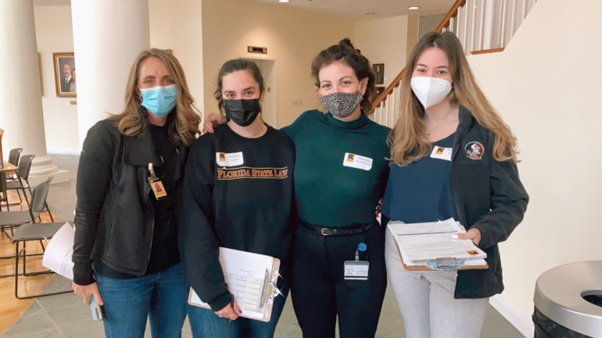

The Florida State University Children's Advocacy Clinic launched a Medical-Legal Partnership with the Nemours Children's Hospital of Orlando, Florida. This partnership provides services to restore and improve the health and well-being of children by addressing legal needs through virtual screenings and remote legal services. Through collaboration between law students, social workers, and medical personnel, holistic representation is provided to children referred through the Medically Complex Coordination Clinic.

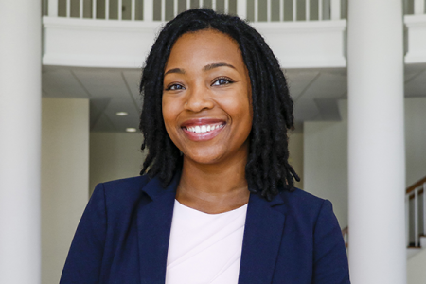

Fordham Law School

In the Securities Arbitration Clinic, directed by Paul Radvany, students advocated at two arbitrations, one lasting 2 days and the other 5 days. In the first, the clinic’s client’s life savings, approximately $11,000, was invested by a broker in an illiquid real estate investment. The client only learned the investment was illiquid when he tried to access the funds to help his mother in Haiti. The clinic won an award of $27,000. In another case, the clinic’s clients’ broker put most of their savings in one, small, biotech stock and lost approximately half of their investments. The arbitration involved six witnesses including an expert. The clinic is waiting for the judgment. The clinic’s students also presented at a webinar sponsored by the U.S. Securities and Exchange Commission aimed at preventing older investors from being defrauded.

Parole Information Project – The Fordham Law Clinic is leading the charge against the crisis of mass incarceration in this country, using innovative ways to turn the tide against a parole system that is broken and overwhelmingly punishes people of color. Professor Martha Rayner and her students in the Criminal Defense Clinic, are attacking the problem from the back end, by untangling New York State's parole system.
The Parole Information Project is a unique data base of parole documents, that aims to make the archaic, Byzantine parole and parole appeal process easier to navigate and more transparent. Not many people, especially new lawyers, know that information about an incarcerated person's parole record is virtually impossible to obtain.
Getting the data alone was not enough. There was clearly an access to justice issue -- parole applicants who had been denied needed representation. Rayner collaborated with Michelle Lewin from The Parole Preparation Project to recruit and train pro bono lawyers at law firms in the parole appeals process. Prior to this, students in the Criminal Defense Clinic, under the supervision of Martha Rayner and Cheryl Bader, handled such cases.
Students in the Legislative and Policy Advocacy Clinic under the direction of Elizabeth Cooper, in coalition with the Feerick Center for Social Justice, were key players in successfully urging the New York State Assembly and Senate to pass the Fair Consumer Interest Rate Bill. This bill would reduce the statutory interest rate in New York in court-ordered, consumer debt judgments from 9% to 2%.
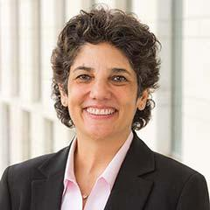
Elizabeth Cooper

George Washington University Law School
In recent months, GW Law has continued to rapidly grow its Clinical Program. In Spring 2022, GW’s first two-credit clinical offering was created recognizing that not all students are able to devote the credits necessary to enroll in a capstone clinic. This smaller clinical offering is intended to help provide the professional development, lawyering training, and identity formation opportunities afforded by capstone clinics to as many GW Law students as possible.

The first division of the Civil Access to Justice Clinic (Family Division) was so successful that two additional divisions will launch in Fall 2022, including the Medical-Legal Partnership Division and Employment Law Division. As the Clinical Program moves into its sixth decade of excellence in clinical legal education, we remain dedicated to expanding our clinical offerings. To read the recent announcements about our Intellectual Property & Technology Law and Criminal Defense and Justice Clinics please read our Newsletters released in November 2021 and February 2022.

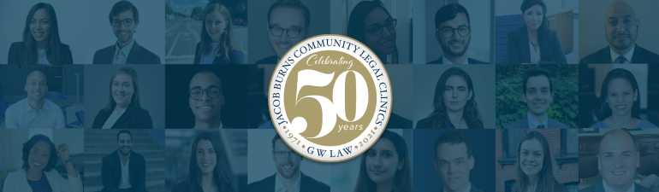
Since 1971, GW Law has recognized the critical role of clinics in helping law students develop vital skills and values, while also providing direct legal services to clients who may not otherwise have access to justice or economic opportunity. To celebrate the 50th anniversary of the GW Law Clinics, alums around the globe are taking time to reflect on their experiences in the Clinic. We are thrilled to honor our stellar alumni community, which is among our proudest achievements. Please click
https://www.law.gwu.edu/clinics-50th-anniversary-alumni-profiles to see what our alums have had to say about their experiences.
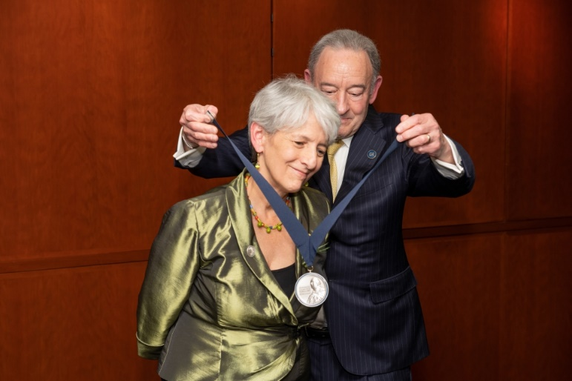
A $2.75 million gift from an anonymous donor recently endowed the new GW Law National Family Violence Law Center Professorship, ensuring that the Director position - and the National Family Violence Law Center at The George Washington University Law School - continue in perpetuity. In recognition of her groundbreaking work to support victims of domestic violence, George Washington University installed GW Law Professor Joan Meier as the inaugural holder of the National Family Violence Law Center Professorship. Professor Meier’s formal Professorship Induction Ceremony was on March 24, 2022, which you can learn more about here.
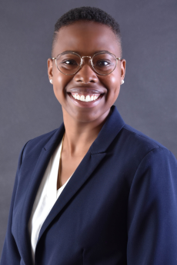
The GW Law Clinic Program is thrilled to have Clinic Alum Andrea Willis-Johnson return to the GW Law Clinics that trained her during her time in law school. In August 2021, Mrs. Willis-Johnson became the Managing Attorney of the GW Law Clinics, which is an administrative leadership position supporting the work of each of our clinical programs. The Clinics have already benefited tremendously from her strategic vision, execution, and experience with corporate compliance and business law. She also supports the Clinical Program’s Racial Justice and Social Equity in Public Interest Lawyering Reading Group.

Georgetown University Law Center

Students participating in Georgetown Law’s Criminal Justice Clinic and Criminal Defense and Prisoner Advocacy Clinic have continued their work on compassionate release cases and continued to rack-up wins. This semester, after already submitting a successful application for compassionate release for one of her clients, a student under the supervision of clinic co-director Associate Professor Vida Johnson successfully argued to have the D.C. Superior Court recognize sentence disparity as a basis for release. Although the federal courts have recognized the basis, there were no D.C. precedents until the student was able to not only secure the release of her client but also help shape the law in the District.

Also in the District, the DC Attorney General has introduced a bill (the Stop Discrimination by Algorithms Act) - which is based closely on a proposal written by the students in the Communications and Technology Law Clinic. Led by clinic director Associate Professor Laura Moy, the students’ proposal updates civil rights protections to prohibit the use of biased or discriminatory algorithms to inform decisions that significantly impact people’s lives (in areas such as housing, employment, education, and health care). If passed, the SDAA will be the first comprehensive law against algorithmic discrimination in the United States.
Meanwhile, the Environmental Law and Justice Clinic is in its first year under Director Sara Colangelo, Visiting Professor of Law. The Clinic will produce two Supreme Court amicus briefs for this term’s environmental cases. The Clinic’s other environmental justice advocacy projects include: filing comments on proposed nuisance regulations and developing a community action guide for DC residents over-burdened by legacy pollution; drafting a rulemaking petition to propose regulatory changes to protect oil spill response workers nationwide, including prison inmate laborers, from the health effects of chemical oil dispersants; and evaluating policy options for a national environmental non-profit regarding development of renewable energy on public lands, with a focus on tribal interests and just transition considerations.

Penn State Law

Penn State Law in University Park hosted the U.S. Court of Appeals for Veterans Claims for a two-day visit, March 23 and 24, 2022, including a live oral argument. The visit gave students an immersive learning experience and a behind-the-scenes look into careers in the field of veteran’s law.

Penn State Law held a Symposium on the Ethics of Immigration Enforcement with ten experts. The two-day event, March 17 and 18, was co-sponsored by the Penn State Rock Ethics Institute, Penn State Law Center for Immigrants’ Rights Clinic, Latina/o Studies, Department of Philosophy, and Schreyer Honors College.

The Penn State Law Civil Rights Appellate Clinic filed an amicus brief with U.S. Supreme Court for National Employment Lawyers Association against Southwest Airlines arguing airline cargo loaders are not subject to the Federal Arbitration Act, that was highlighted by Bloomberg, as Amazon, Lyft, and Uber care about case impact.

Penn State Law Board of Advisors member Sarah FitzGerald Mika, and her husband, Andrew J. Mika, have endowed a $25,000 program fund to benefit the Family Law Clinic, which gives students the opportunity to represent victims of domestic abuse and other individuals in divorce proceedings and child custody cases.

Pepperdine Caruso School of Law

The Pepperdine Caruso School of Law launched the Religious Liberty Clinic in Spring 2022. In the Clinic, second and third-year students work on religious liberty cases under the direction of Visiting Professor Eric Rassbach, Professor Michael Helfand, and supervising attorneys from Jones Day.
The clinic explores enduring questions relating to government treatment of religious beliefs, expressions, and institutions. Rassbach, vice president and senior counsel at the Becket Fund for Religious Liberty, serves as the inaugural faculty director of the clinic, teaching alongside Professor Helfand.
On March 2, 2022, the Religious Liberty Clinic filed its first amicus brief at the United States Supreme Court in support of Joseph Kennedy’s appeal against the Bremerton School District. Submitted on behalf of The American Legion. Joseph Kennedy, a high school assistant football coach, was fired by the school district because he engaged in private prayer on the field after games.
Joseph A. Kennedy vs. Bremerton School District will be argued at the Supreme Court later this April. The Court’s opinion on the case is expected by the end of June.
The Pepperdine Caruso Law brief may be read at https://law.pepperdine.edu/nootbaar-institute/content/kennedy-amicus-brief.pdf
Saint Louis University School of Law

New Children’s Permanency Clinic
SLU Law welcomed Professor Kathryn Banks and celebrated the launch of her Children's Permanency Clinic. The CPC works with children and families in the St. Louis area who are impacted by involvement with the court system. Students have appeared on child order of protection cases, custody cases, and guardianship cases to elevate the voice of children in court proceedings. The CPC also launched a collaboration with the Missouri State Public Defender's Children's Defense Team to work on sealing juvenile court records.

Abolition Reading Group
Professor Lauren E. Bartlett (Director of the Human Rights at Home Litigation Clinic) collaborated with Professor Chad Flanders and Emanuel Powell (Skadden Fellow & Staff Attorney at ArchCity Defenders) to lead a weekly Abolition Reading Group focused on the topic of "the role of lawyers in abolitionist movements and broader social change.” The group started with Derecka Purnell’s Becoming Abolitionists and moved on to other directed readings. Discussions ranged from policing, prisons and jails, immigration detention, and courts to movement lawyering and freedom dreaming.

Criminal Defense Clinic
Staff Attorney Matt Vigil and his student used a recently expanded Missouri law to successfully petition the court for expungement of a client’s 20-year-old conviction. Though this was the client’s only conviction, it had been a serious barrier to employment. The clinic also began implementing a wellness curriculum. Inspired by Ronald Tyler’s influential article, “First Thing We Do, Let’s Heal All the Law Students,” Professor Susan McGraugh (clinic director) and Lauren Choate (clinic social worker) aim to educate their students not just on the technical practice of law, but also the emotional practice of defense. Viewing the clinic as a “public defense incubator,” they seek to prepare students to be able to engage in this work in a long-term, healthy way. Additionally, they hope this curriculum will help students reduce dysfunctional stress and better function in law school.

St. Mary’s University School of Law

The Criminal Justice Clinic has partnered with the Bexar County District Attorney’s Conviction Integrity Unit in an effort to bring justice to victims of a disbarred and convicted former defense attorney who coerced guilty pleas from women through abusive and exploitive behavior. Our Clinic has been appointed to review twenty related cases for possible post-conviction relief. Additionally, Clinic students are preparing an Amicus Curiae brief on an issue of first impression regarding parole revocation timelines in Texas, which emerged as a problem during the COVID-19 pandemic.

Immigration and Human Rights Clinic students won an appeal filed with the Board of Immigration Appeals for a client from the Democratic Republic of Congo. This successful appeal, overturning the Immigration Judge’s decision, resulted in a quick grant of asylum for their client. The same students who handled the appeal had represented the client in his initial immigration court proceedings, so it was especially gratifying for them to see the case through to the end with an asylum grant.

Consumer Protection Clinic Professor Genevieve Fajardo moderated a panel on code enforcement and demolitions in San Antonio, which brought together experts from the University of Texas School of Law, University of Texas at San Antonio, and Trinity University, to discuss the city’s code enforcement practices with the Director of the City’s Development Services Department.

Our Consumer Protection Clinic and Pro Bono Program participated in the White House and Department of Justice Convening of Law Schools, which highlighted the efforts of law schools to respond to the eviction crisis resulting from the COVID-19 pandemic. Since June 2020, the St. Mary’s Law Housing Hotline—a collaboration with Texas RioGrande Legal Aid, San Antonio Legal Services Association, and the University of Texas School of Law—has fielded calls from more than 2,000 residents.
Seton Hall University School of Law

With funding from the Legislature, Seton Hall Law School and Rutgers Law School established the New Jersey Housing Justice Project at the start of the 2021-22 academic year. The Project is expanding individual representation as it advocates for broader social change, including work in the area of the implementation of landlord-tenant reform and equity impact analysis in the landlord-tenant arena. At Seton Hall Law, the Project is part of the Center for Social Justice and includes three faculty who are teaching clinics – Professors Kevin B. Kelly and Abdul Rehman Khan in the Civil Litigation Clinic and Professor Rachel Gerson in the Health Justice Clinic – as well as Diane K. Smith, Managing Attorney, Lori Outzs Borgen, CSJ Director, and more than two dozen clinic students and volunteers. The Project has also established a Housing Justice Corps to provide fellowships to recent graduates and transitioning attorneys to undertake housing advocacy. In February 2022, the Project issued a Report on Observations on the Implementation of Landlord-Tenant Reform in New Jersey.

After more than four years of litigation by the Center for Social Justice and pro bono counsel, the Essex County Superior Court granted final approval to two landmark class action settlements which provide a rent rebate for residents and an accelerated repair schedule to federally subsidized Section 8 buildings in Newark, NJ. The complaints alleged that the poor condition of the apartments constituted a breach of the implied covenant of habitability. According to the terms of the settlement with the former owner and management company of the apartment complex, residents who lived at the subject properties during the relevant time period and who opted into the settlement are entitled to compensation. In addition, all the buildings that were subject to this lawsuit will be renovated on an accelerated schedule. For question about the cases, contact Professor Kevin Kelly at kevin.kelly@shu.edu.

SMU Dedman School of Law

The Small Business Clinic, under the leadership of Professor Kandace Walter, has initiated a new collaboration with Incubator@SMU, a dedicated business workspace that exists to encourage and facilitate the formation and growth of new organizations founded by SMU faculty, staff, students, and alumni. Clinic students have drafted company agreements and trademark applications and helped their clients form LLCs and nonprofits.

Professor Mary Spector, Director of the Civil Clinic, piloted a court observation project in Dallas County’s eviction courts. The project is a partnership with the Child Poverty Action Lab (CPAL) and a collaborative of advocacy groups, nonprofits, and government agencies with the shared goal of combatting child poverty. The pilot has since expanded with additional law students through the school’s Public Service program and is expected to expand to all 10 Dallas County eviction courts over the summer.

In a related project with CPAL, public service students are also working with Prof. Spector and SMU’s Data Science Center to gather demographic data about tenants not available through court observations or other public records. Data collected in both projects will support advocacy on behalf of tenants locally and throughout the state.

Texas A&M University
Environmental and Natural Resources Clinic

TAMU School of Law added a new clinic where students represent and work with entities to address local, state, and federal concerns related to the use, conservation, management, and protection of land, water, air, the environment, habitats, species, and other natural resources.

Immigrant Rights Clinic

Professor Fatma Marouf and her students won an Egyptian asylum case in immigration court, obtained humanitarian parole for the parent of a seriously ill child, successfully filed a mandamus for a client Cameroon, and obtained prosecutorial discretion for a number of clients. The Clinic also submitted a complaint to the DHS Office for Civil Rights and Civil Liberties about ICE’s use of a restraint device called The WRAP. Additionally, the Clinic drafted a report on civil rights violations against Black immigrants in the South. In May 2022, one of the Clinic’s clients is scheduled to testify before the U.S. Senate about medical abuses at the Irwin County Detention Center.
Texas A&M Externship Program
Our Externship Program offers students opportunities to pursue interests and gain practical experience. We offer students the ability to extern full-time through our Residency Externship in Public Policy Program in Washington DC and Austin, Texas, as well as our Residency Program: Semester-in-Practice, where students can extern in diverse geographic and practice areas.
Director of Entrepreneurship Community Development Clinic, Luz Herrera
Luz Herrera was recently Awarded the Foundation’s Partner in Philanthropy Award, a monetary award and honor. This award is for dedicated service in building philanthropic partnerships such as the TAMU Cook Children’s Medical Legal Partnership, legal clinics as well as work within the Rio Grande Valley.
University of Baltimore School of Law

The University of Baltimore School of Law approved a new in-house criminal defense clinic. We are excited to add this clinic to our existing line up of criminal clinic offerings including our Criminal Practice Clinic and Innocence Project Clinic. On June 17, 2022, the Bob Parsons Veterans Advocacy Clinic at the University of Baltimore School of Law will host the 13th Annual Veterans Legal Assistance Conference & Training. In calendar year 2021, the Low-Income Taxpayer Clinic (LITC) reduced assessments to clients by $347,293.00. The LITC is directed by Melinda Dunmire, Professor of the Practice, and also taught by Sakinah Tillman, Clinical Teaching Fellow.

UDC School of Law

In March 2022, UDC Law launched Conversations with Clinicians, an online series intended to spark conversations across the experiential education community. Each conversation features a UDC Law clinician hosting leading clinicians from across the country to discuss a topic of interest to the clinical community. A pioneer in clinical legal education, UDC Law remains deeply committed to the advancement of clinical education. We began the series on March 11 with UDC Law Dean Renée Hutchins in conversation with University of Maryland’s Michael Pinard, discussing career trajectories for clinicians.

On March 25, UDC Law Associate Dean for Clinical and Experiential Programs, Lindsay M. Harris, hosted Professor & Associate Provost Laila Hlass of Tulane and Assistant Dean for Experiential Education Allison Korn of UCLA to examine trends in experiential legal education discussed in their article, Assessing the Experiential Revolution. On Friday April 22, UDC Law General Practice Co-Director, Tianna Gibbs, engaged with Prof. Norrinda Hayat, Director of the Civil Justice Clinic at Rutgers Law, to discuss Prof. Hayat’s critically important 2021 Clinical Law Review piece, Freedom Pedagogy: Towards Teaching Antiracist Clinics. We anticipate continuing the series in the Fall. To access recordings of prior sessions, visit the Conversations with Clinicians page here: https://bit.ly/UDCLawCwC

We are thrilled to announce that our new Managing Attorney, Tiffanny Smith, joined us mid-semester. Working closely with the Associate Dean to oversee the Clinical Program, Tiffanny comes to us with experience working on special education advocacy, as a GAL in high-conflict custody cases, advocating for the human and civil rights of incarcerated individuals, with incarcerated domestic violence survivors, and managing pro bono projects focused on family law, senior law, and criminal expungement. Tiffanny, along with staff assistants Miguel Aguero and Tamara McGuire, works to support UDC Law’s Clinical Program

UC Davis School of Law

The externship class enrolls nearly 100 students every year who work in primarily judicial, government and public interest offices in part-time and full-time placements. Professor Dena Bauman, who joined UC Davis in Spring 2019, has implemented changes to strengthen the educational component and expand the types of opportunities for students. This past year, she taught a one-unit seminar that all students took in addition to their field placements. The seminar focused on the core themes and values of professionalism and professional identity. Students met in small sections to discuss their placements, systemic issues, and to problem solve with each other. In addition to reflective journals, students completed time management and wellness assignments.

This spring, the faculty gave permanent approval for three pilot initiatives: a corporate counsel option and a Southern California judicial option. Students also may be compensated by their placements (the ABA removed the prohibition on paid externships in 2016). Students may also intern in Washington DC through the UCDC program.

UC Hastings

UC Hastings diversified and expanded its Pro Bono Spring Break programs, offering five different opportunities. While some students provided civil legal services in rural New York, many others focused on dire immigration needs and provided direct services to clients seeking asylum in Tijuana, Mexico, El Paso, Texas, and Tucson, Arizona. Professor Richard Boswell designed a new course to prepare some of the students—teaching them to counsel and prepare clients for credible fear interviews. A student-led organization, Hastings-to-Haiti, partnered with the Center for Gender and Refugee Studies, and made national news when Legal Director Blaine Bookey and students successfully represented a Ukrainian family who was being denied entry to the United States. The incident has been cited in the increased pressure on the government to end Title 42 restrictions.

Our Clinical Programs’ faculty continue to update and refine their curriculum to address racial justice and diversity in the classroom and work to share new ideas with others. For example, In February, Director of Externships Professor Nira Geevargis presented to Stockton University's Committee on Campus Diversity and Inclusive Excellence to share a revised version of its 2011 Diversity Profile--a matrix that allows students to assess whether their intercultural experiences from childhood through law school have been clustered and whether their perceptions about those experiences are accurate. Professor Geevargis spent the last two years refining the tool with feedback from externship faculty and students. She has presented to clinical colleagues on the statewide and national level about utilizing the Diversity Profile. After collaborating with Professor Geevargis, Stockton Assistant Professor of Business Studies-Management Joy Jones plans to use the Diversity Profile in her Business Communication, Management Skills Development, and Women in Protest courses this fall.

University of Houston Law Center
Despite the overwhelming challenges presented by COVID-19 and remote learning, the UHLC Immigration Clinic continued expanding our impact and reach while experiencing notable successes. Of note, the Clinic hosted two virtual CLE programs pertinent to changes in immigration enforcement and policy, both of which were attended by more than 300 advocates. Justice Sotomayor issued a compelling dissent in support of one of our Haitian clients with mental incompetency issues, despite SCOTUS otherwise rejecting to grant certiorari within the case. We continue seeking opportunities to aid immigrants with claims implicating other legal areas. For example, the Clinic partners with a local non-profit which supports transgender individuals with gender marker and name change petitions by providing consultations to trans-immigrants about the possible ramifications upon their immigration case that may result from their legal documents changing to reflect their gender identity.
University of Maryland Carey School of Law

The school is delighted to announce that we will be adding two clinics next year: an Appellate Immigration Clinic, taught by Aadhithi Padmanabhan, and a Criminal Appellate Clinic, taught by Marc DeSimone.

University of Miami

The University of Miami School of Law has had a successful academic year despite the ongoing challenges of the pandemic. The Children and Youth Clinic is fighting against policies that marginalize and isolate incarcerated foster youth. Students used data and statistics to successfully advocate against a statutory change that would have prevented incarcerated youth from participating in independent living services after they turned 18.

The Environmental Justice Clinic partnered with People’s Environmental and Economic Resiliency group and Catalyst Miami to launch the Equitable Weatherization Clinic to focus on creating equal opportunity for access to weatherization services in historically marginalized communities.

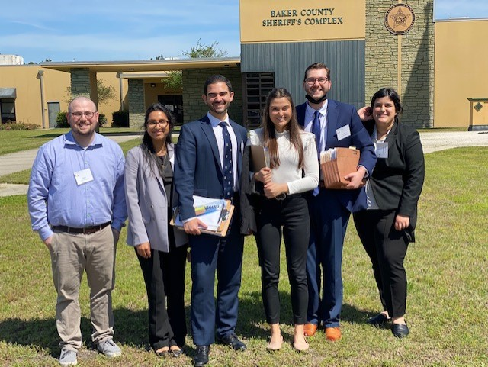

Six students in the Immigration Clinic traveled to Baker County jail near Jackonsville to conduct Know Your Rights presentations and monitor conditions. Students won the release of a Mexican woman from Immigration and Customs Enforcement detention at the jail.

The Human Rights Clinic contributed to a victory for the right to food in West Virginia as City of Morgantown adopts new municipal resolution. The Clinic is working to create a People’s Implementation Manual for the state of Maine that will serve as a guidebook on how to implement the right to food.

The Innocence Clinic and the Health Rights Clinic worked together on behalf of a Health Rights Clinic client, to vacate the client’s two felony traffic cases. The judge granted the clinic’s motion, and the Health Rights Clinic is now one step closer to being able to obtain Temporary Protected Status.

University of Nevada, Las Vegas

The UNLV William S. Boyd School of Law announced a $1 million endowment for its Externship Program thanks to a gift from Sam and Lexy Lionel. This gift will establish the Samuel S. Lionel Externship Program, which recognizes Mr. Lionel’s significant and lasting contributions to the Las Vegas legal community and provides support to Boyd students as they gain practical experience in the externship program.

The law school’s Samuel S. Lionel Externship Program will continue to be directed by Professor Dawn Nielsen, a Boyd alum with a deep commitment to experiential legal education. Thanks to the Lionels’ continued generosity and under Professor Nielsen’s leadership, the law school will now be able to enhance program offerings, hire Lionel Fellows to assist with the classroom component of the program, and provide scholarships to students in placements serving underrepresented communities throughout Nevada.

USC Gould School of Law

The USC Law International Human Rights Clinic (USC IHRC) published a comprehensive report documenting how US law enforcement’s sex trafficking operations fail to protect victims, rarely lead to prosecution of traffickers, do not successfully prevent trafficking and have disproportionate harmful impact on minority victims. Read the full report here.

USC IHRC’s findings and recommendations in a report to the United Nations High Commissioner for Human Rights on systemic racism in U.S. law enforcement against peaceful protestors were cited 12 times in her report to the United Nations Human Rights Council on global systemic racism against individuals of African descent.

University of South Carolina

The Carolina Health Advocacy Medico-Legal PartnerShip (CHAMPS) and CHAMPS Clinic is beginning a collaboration with the Access to Justice Lab at Harvard Law School to study the impact on medical-legal partnerships on child welfare referrals.

During the fall 2021 semester, the Domestic Violence Clinic secured several Orders of Protection to protect clients from intimate partner violence and secured citizenship and a green card for clients who sought immigration relief through the VAWA Self-Petition process. In addition, the Domestic Violence Clinic filed an amicus brief with the South Carolina Court of Appeals advocating for the recognition of minors as persons entitled to protection through the Order of Protection remedy

The Environmental Law Clinic continues to expand its substantive focus on environmental justice alongside conservation efforts, including work on heirs' property, community benefits agreements, brownfields remediation, plastics regulation, and floodplain resilience.

In the fall of 2021, the Juvenile Justice Clinic represented and won the release of 3 children in juvenile parole hearings.

University of Tennessee

The University of Tennessee Legal Clinic has launched a new Transactional Legal Clinic (TLC) co-taught and designed by Professors Eric Amarante and Brian Krumm to teach our students transactional skills and improve the student experience by increasing viewpoint diversity in the clinic classroom.

The Domestic Violence and the Family Mediation Clinics joined forces to develop interactive presentations for the Family Justice Center’s Domestic Violence Conference. They trained non-lawyers to prepare successful petitions and raised challenging questions about the role of mediation.

The University of Tennessee Legal Clinic is celebrating its 75th Anniversary this year on October 21st – and you are all invited!

Rick Rose, an alum, generously donated $250,000 to fund our first UT Clinic Teaching Fellowship! Stay tuned for a job announcement! We are building an endowment over the next 5 years to support two UT Clinic Teaching Fellows.

Since the fall of 2020, clinic faculty have been working on a Racial Justice Listening Project. We have generated reports, restructured our clinic intake, and are creating a community-facing website. This semester, we launched two new courses. In The Visions of Justice Practicum taught by Professor Wendy Bach and Sociology Professor Michele Brown, law students and graduate students are working on behalf of community organizations to gather information about school safety and policing policies and to conduct focus groups on visions of safety in East Knoxville, the part of our community most directly impacted by violence. In Bail Reform in Tennessee, taught by Professor Joy Radice, 14 law students are learning alongside community organizers from Community Defense of East Tennessee. Attorneys from Southern Poverty Law Center and Civil Rights Corp. have taught classes, and the students are conducting a court watching project with full IRB approval to gather data about the magistrate bail hearings and court proceedings in Knox County.

University of Washington School of Law

Immigration and Race and Justice Clinic Students Help Detained Immigrant Children Over Spring Break

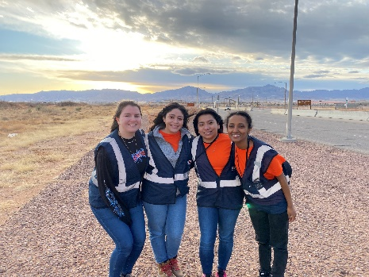
UW Law students from the Immigration Clinic and Race & Justice Clinic traveled to the U.S.-Mexico border over Spring Break to provide legal services to detained immigrant children at the Fort Bliss Emergency Intake Site (EIS) in El Paso, Texas. The UW Law team worked with 1,300 children, over a third of whom spoke an indigenous language leaving them unable to access information and services that are generally provided in Spanish. During the week, the UW Law team supported over 1,000 children in getting critical information regarding their legal rights and met individually with 120 children to screen and interpret “Know Your Rights” presentations.

Youth Advocacy Students Work on Two Statewide Projects with Potential National Implications
UW’s Youth Advocacy Students worked to expand upon the state legislature’s recent decision to provide the right to counsel for all children eight years of age and older in dependency proceedings. Students joined the Statewide Children’s Representation Workgroup and authored a masterful, anti-racist focused, report recommending that the right to counsel be extended to children under eight years old. The report was adopted by the Statewide Workgroup and submitted to the WA State Legislature. Two other Youth Advocacy students wrote a policy brief at the request of U.S. Congressman Danny K. Davis of Chicago. The policy brief, designed to support legislative proposals, focuses on pregnant mothers at risk of child welfare involvement, most often due to substance use. The model utilizes an interdisciplinary staff of lawyers, social workers, and parent navigators with lived experience, to help mothers avoid separation from their newborns.
Mediation Clinic Launches Cutting-Edge Interdisciplinary Collaboration with Seattle Housing Authority
This winter, UW Law’s Mediation Clinic launched a pilot program, titled Conflict Resolution Services (CRS) in collaboration with the Dispute Resolution Center of King County (KCDRC) and Housing Connector (HC). The program is designed to support Seattle Housing Authority residents through early, prompt, and impartial intervention designed to resolve housing conflicts before they escalate. In a collaborative effort with stakeholders, our team designed a conflict intervention program that will be qualitatively and quantitatively evaluated by Professor Gregg Colburn (UW’s College of Build Environments) and a public policy PhD student. Test cases begin next month and include a strong feedback loop, allowing us to iterate on our program design as we move forward.
University of Wisconsin Law School
The Economic Justice Inst. at the University of WI Law School is adding a new fellow position starting in the fall of 2022. The Eviction Defense Project will be adding a second clinical instructor. U of WI Law now offers more flexibility to clinical students, including two semester, one semester and summer programs and a variety of credit levels.
Wake Forest University School of Law

Under the supervision of Professor Zaneta M. Robinson, the Wake Forest Law Intellectual Property Law Clinic was granted law school clinic certification by the United States Patent & Trademark Office.

The Wake Forest Law Medical-Legal Partnership (MLP) Clinic presented at the White House and Department of Justice Convening of Law Schools. The event, hosted by Attorney General Merrick Garland and Second Gentleman Douglas Emhoff, recognized innovative law school responses to the Attorney General's Call to Action to address the COVID-19 Eviction Crisis. The MLP Clinic is directed by Professor Allyson E. Gold.

Washington University School of Law

Low Income Taxpayer Clinic Welcomes Back Tax Court S.T. Judge Choi

The Low Income Taxpayer Clinic welcomed back its former supervising attorney, Eunkyong Choi, to discuss her new role as the first Asian-American Special Trial Judge in the U.S. Tax Court. Judge Choi gave students a behind-the-scenes glimpse of how Tax Court works and shared how her experience in WashULaw’s Low Income Taxpayer Clinic influences her perspective as a jurist.

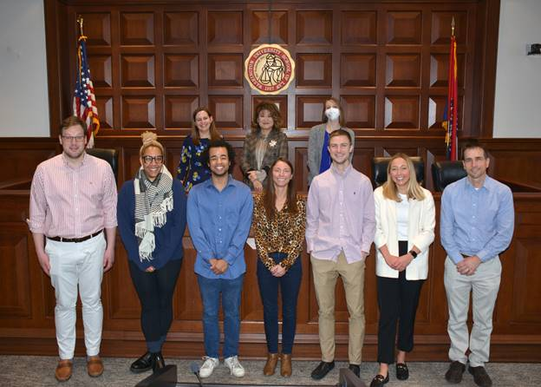
LITC Students (front) meet with Tax Court Judge Eunkyong Choi (back center). Also pictured, LITC Director Sarah Narkiewicz (back left) and Supervising Attorney Jennifer Stoll (back right).

Interdisciplinary Environmental Clinic Comments on Proposed Regulations

Long one of the most contentious aspects of the Clean Water Act, the “waters of the U.S.” regulations were again the subject of a national rulemaking. Students from the Interdisciplinary Environmental Clinic drafted comments on the proposed rule on behalf of a client, emphasizing the need to protect the unique environmental features of the Missouri landscape.

First Amendment Clinic Represents Musicians in Obstruction Ordinance Case

The First Amendment Clinic “FAC” represented musicians in a challenge to a municipality’s obstruction ordinance used to prohibit musicians from playing music on public sidewalks and on adjacent private areas. The FAC asserted the ordinance violated the First Amendment and Due Process Clause. The federal district court granted, in part, the FAC’s motion for summary judgment in the musicians’ favor, holding the city violated the musicians’ rights. The remaining claims were dismissed as part of a settlement between the plaintiffs and municipality that included a payment to the musicians.

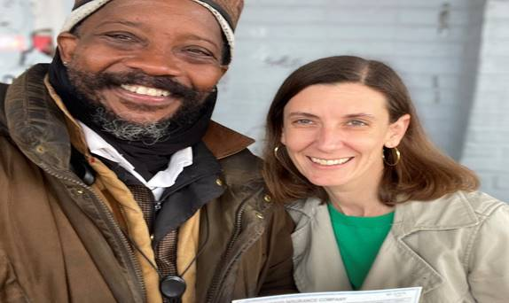
First Amendment Director Lisa Hoppenjans presents settlement payment to client Raven Wolf Jennings.

The Appellate Clinic Visits the Missouri Court of Appeals

The Appellate Clinic spent the morning with Chief Judge Sullivan of the Missouri Court of Appeals to discuss the Missouri appeals system and the dos and don’ts of appellate advocacy. They will be putting their appellate skills to use when they argue a case before the 6th Circuit Court of Appeals later this month.

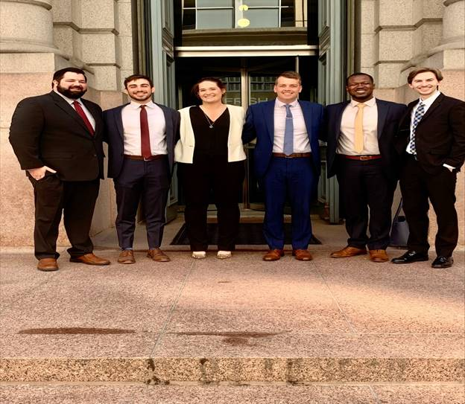
WashULaw Appellate Clinic students in front of the Missouri Court of Appeals.

West Virginia University College of Law

Stephanie M. Coleman has been appointed Director of the Low-Income Taxpayer Advocacy Clinic. Before joining WVU, she served as Director of the LITC at West Virginia Legal Aid and later as both LITC Director and Managing Attorney at Rhode Island Legal Services. She brings extensive tax controversy experience to the law school’s clinical program.

West Virginia Innocence Project, in collaboration with The Innocence Project’s state policy advisor, drafted junk science legislation that was introduced by Delegate Joshua Higgenbotham (R-Putnam) and signed into law by Governor Jim Justice in April 2021. The new law provides an avenue for relief for people who were convicted using debunked or outdated forensic science.

The Immigration Clinic will be running a special Afghan legal representation project this summer, representing Afghans who face a deadline to apply for asylum or other immigration relief. It will be staffed by two attorneys, two law students, and we are currently hiring a paralegal through the AmeriCorps VISTA program. We also will represent some Ukrainians and may expand that representation next year.

The Veterans Clinic worked to extend its reach by utilizing space in Charleston WV to reach more veterans in need. The students have taken advantage of access to the legislature to advocate for issues that affect veterans.

The West Virginia University Entrepreneurship and Innovation Law Clinic assisted over 20 small businesses, nonprofits, and government instrumentalities in areas such as formation, intellectual property protection, employment matters and internal policy development. The EILC students worked on proposed legislation designed to limit fraudulent misrepresentations commonly found in small business solicitations and testified in front of the state legislature on the proposed bill.

Committee Announcements

Communications Committee

The AALS Clinical Section's Communications Committee is thrilled to announce three new members who will be starting with the committee in the upcoming school year: Nickole Miller of Drake University Law School, Jennifer Prusak of Vanderbilt University Law School and Becky Sharpless of University of Miami School of Law. With these three new members on board, three members who have long served the committee will be stepping away: Kim Ambrose of University of Washington School of Law, Michael Martin of Fordham University School of Law and Gail Silverstein of UC Hastings Law. The Committee is grateful for their dedicated service. Keeshea Turner Roberts of Howard University School of Law will be the new Committee Chair.
Externship Committee

This spring, our dedicated subcommittees continued to provide structured and informal spaces for our externships colleagues to learn and share.
Our International and Away Externships Committee kicked off the semester with a lively discussion on leveraging externship experiences to promote domestic and international collaborations. The Membership Committee hosted Recess on the third Thursday of February and March. These gatherings gave colleagues a chance to connect and discuss topics important to our work, including ABA standards, and virtual and paid externships. The committee also hosted a popular panel, We Don’t Talk about Bruno Administration, on the administrative part of our roles. Efficient systems are an essential part of running an externships program, so we hope to continue these discussions in the next academic year.

Our Teaching Methodologies Committee has been hard at work. It hosted a roundtable in April with six externships colleagues sharing their favorite teaching ideas in a lightning-round session. This committee is also implementing a Peer Buddy Program where externships professors can connect in pairs to share resources and ideas and shadow each other’s classes (where possible on Zoom).

During the AALS Clinical Conference, the Anti-Racism Think Tank will host a meeting to draft the Externships Committee’s anti-racism mission statement. Our AALs Externships co-chairs, Amanda Rivas and Nira Geevargis, will also lead a collaborative to discuss current topics in our programs, including ABA standards, and paid and virtual externships.

We are grateful to the subcommittees, panelists, and attendees who planned and participated in our sessions this spring.

Please feel free to contact the chairs, Nira Geevargis at geevargis@uchastings.edu and Amanda Riva at arivas@stmarytx.edu.

Membership, Outreach and Training Committee

Back by popular demand, the Membership, Outreach, and Training (“MOT”) Committee is facilitating “Clinician Crews” for the second year. Crews are peer discussion groups for new and experienced clinicians. They replaced the former clinical mentoring program. Participants typically sign up for one academic year, meeting monthly during the semester to discuss topics ranging from clinic design to balancing scholarship and other academic demands. Each Crew decides its discussion topics. If you’re interested in joining a Crew, email co-chair Heather Abraham (Buffalo). Mark your calendars: The Committee will again host a “Coffee Break” tailored to new clinicians (but everyone is welcome!), Wed. May 11 at 10 a.m. ET. The link is on the AALS Clinical Conference program.

Upcoming Meetings and Conferences

Drake Law School will host the Midwest Clinical Conference in person this fall from October 28-30th in Des Moines, Iowa. Please mark your calendars and look for more information in the weeks to come with conference details and a request for proposals (https://bit.ly/3KEXZ7J). Please contact Suzie Pritchett, Directors of Clinics and Experiential Education (suzan.pritchett@drake.edu) with any questions.

Externships 11 – UCLA and Pepperdine, October 2022

We look forward to gathering for Externships 11 in sunny California October 7-9, 2022!
For those who would like to present but have a half-baked or not-at-all baked idea, the deadline to submit an RFP Interest Form has been extended to May 13, 2022, after the AALS Conference. A committee member will be in touch to discuss your interest. The RFP submission deadline has been extended to June 17, 2022. Please mark your calendars.
Also, if you haven’t done so already, please check out the Externships 11 website! You’ll find all the links to complete registration, submit proposals, etc. Please bookmark the page and circulate widely!
https://law.pepperdine.edu/events/symposia/externships-11/
.
We look forward to working with possible presenters, and to seeing all of you next fall in sunny California!

